1. **Instructor:** 
   1. Bharat ThippiReddy.
   2. Software Architecture.
2. **Agenda**:
3. 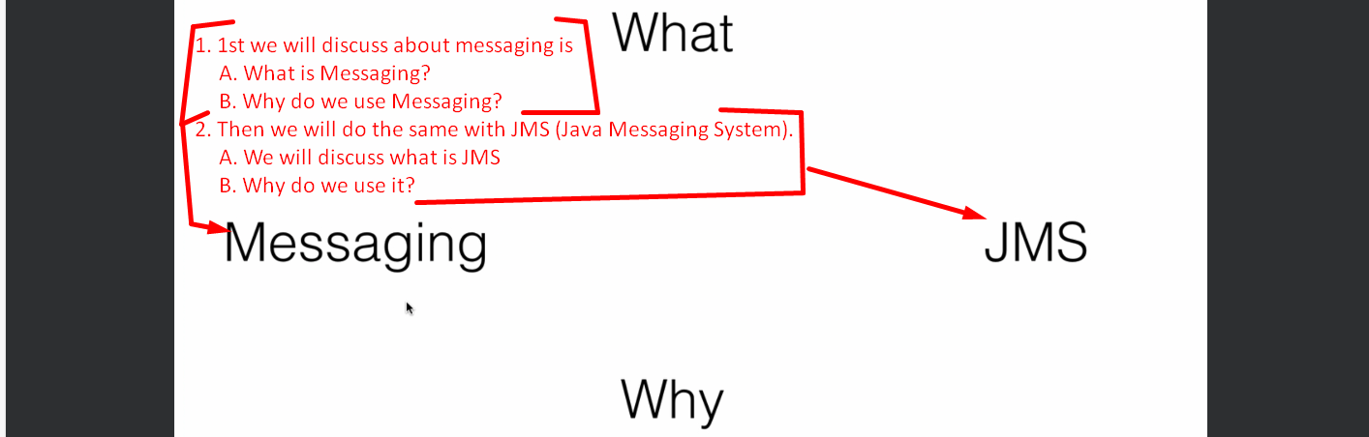
4. 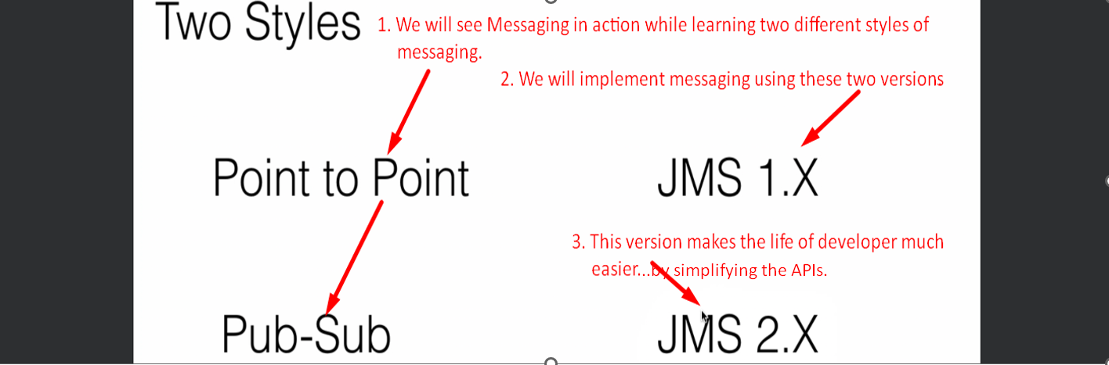
5. We will master the anatomy of msg later on in **Section 5: Anatomy of a JMS**.   
   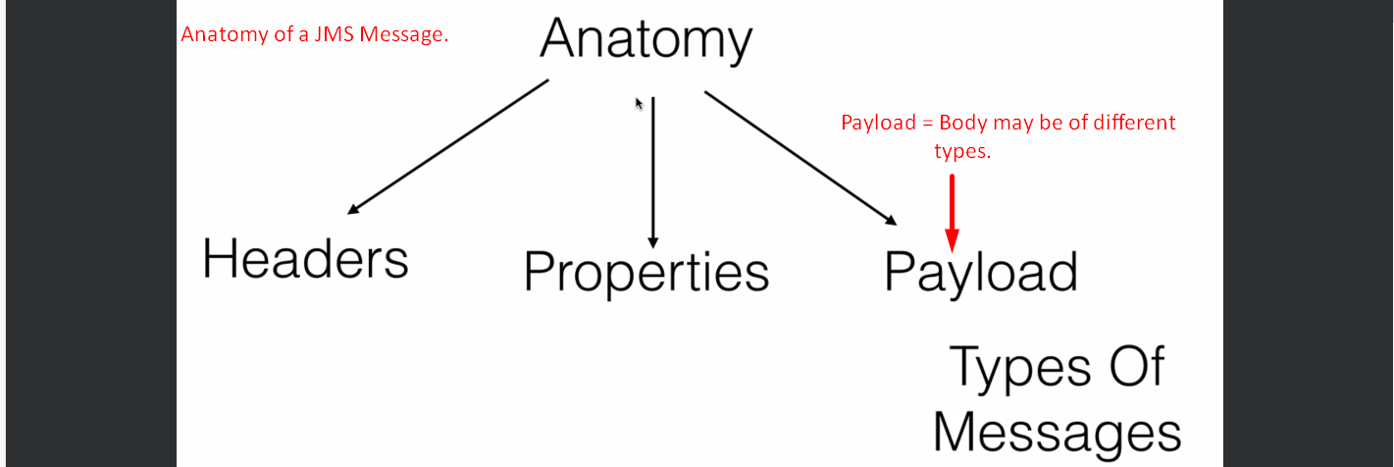
6. 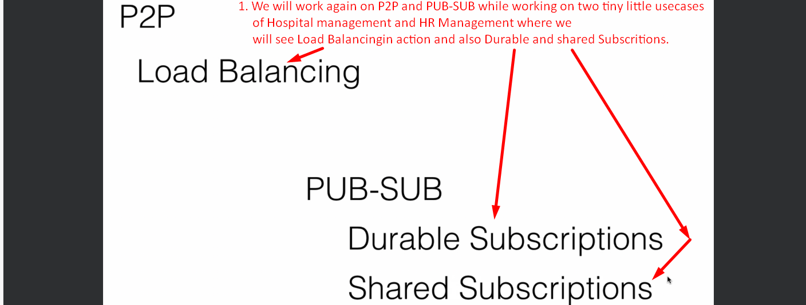
7. 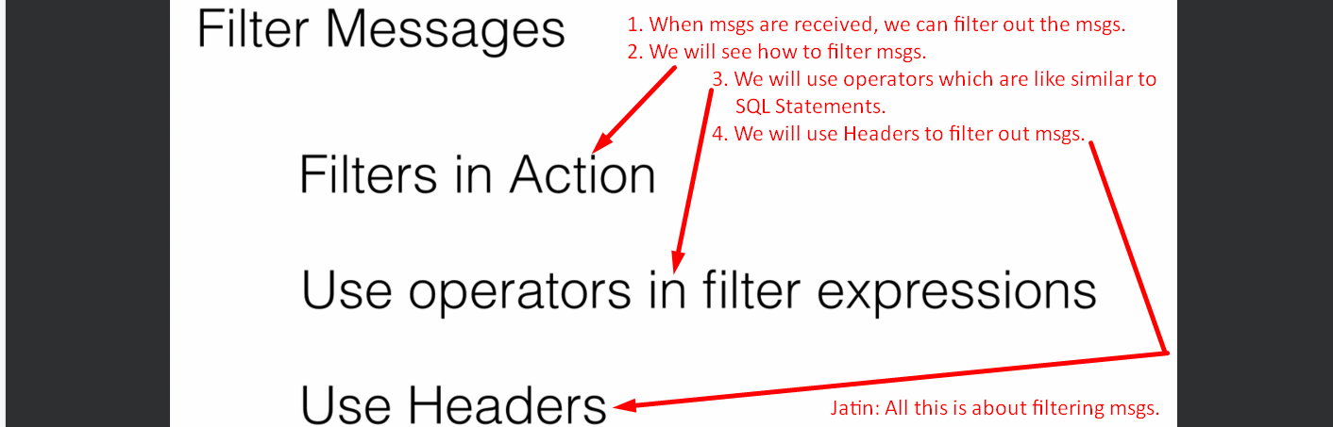
8. **Message Guarantee**:  
   Messaging delivery guarantee is very important for any app.   
   We will do that using **different acknowledgement modes** while sending and receiving the msgs.  
   **Transaction**:   
   We will use Transaction on the producer and the consumer side.  
   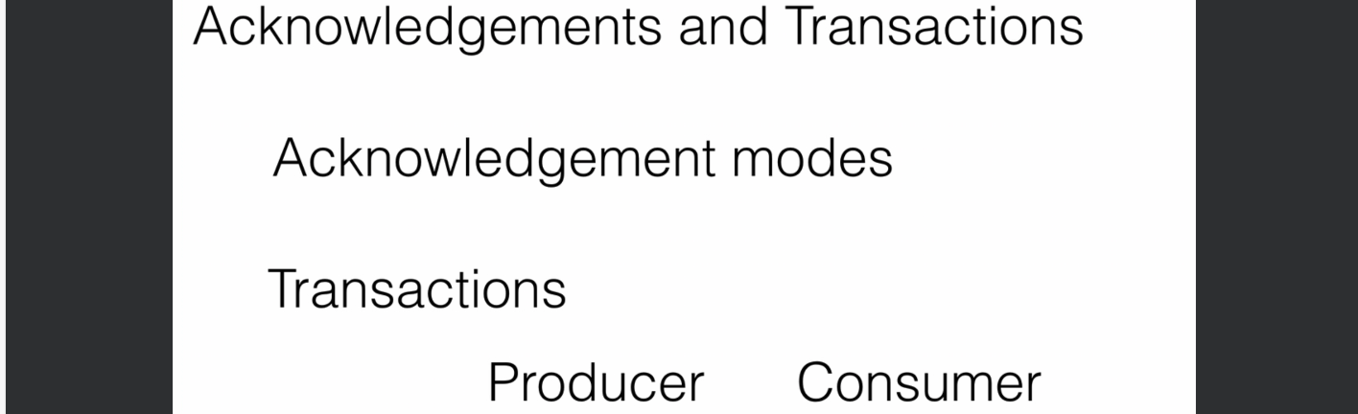
9.   
   I have put one query for the above slide in the lecture Q/A.